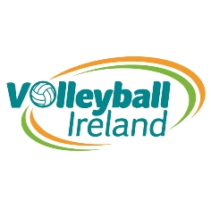

SAMPLE Volleyball Club
Development Plan
2018-2021

Checklist | Objective | Date Completed | BMP Checklist | Objective | Date Completed
Committee Role | Send Committee role Description to club | 22/10/18 | Junior Section | Secured Additional Hall time | Oct 18

Sponsorship/Financial Support
Aim (SAMPLE Volleyball Club)
- (SAMPLE VC to fill in this part) e.g club will actively seek funding opportunities

Objective (SAMPLE VC)
- To seek funding specific to the development of a junior programme within the club, from age 4 to 16.

Action Plan
Objective | How | Responsibility | When | Finance | Completion
What needs to be done | How you intend to achieve the objective

Membership/Junior Membership
Aim (SAMPLE Volleyball Club)
- (SAMPLE VC to fill in this part) e.g Provide information to VI to advertise

Objective (SAMPLE VC)

Action Plan
Objective | How | Responsibility | When | Finance | Completion
What needs to be done | How you intend to achieve the objective

Committee
Aim (SAMPLE Volleyball Club)
- (SAMPLE VC to fill in this part) e.g Organise a club meeting to form a committee and club structure

Objective (SAMPLE VC)

Action Plan
Objective | How | Responsibility | When | Finance | Completion
What needs to be done | How you intend to achieve the objective

Junior Section
Aim (SAMPLE Volleyball Club)

Objective (SAMPLE VC)

Action Plan
Objective | How | Responsibility | When | Finance | Completion
What needs to be done | How you intend to achieve the objective

