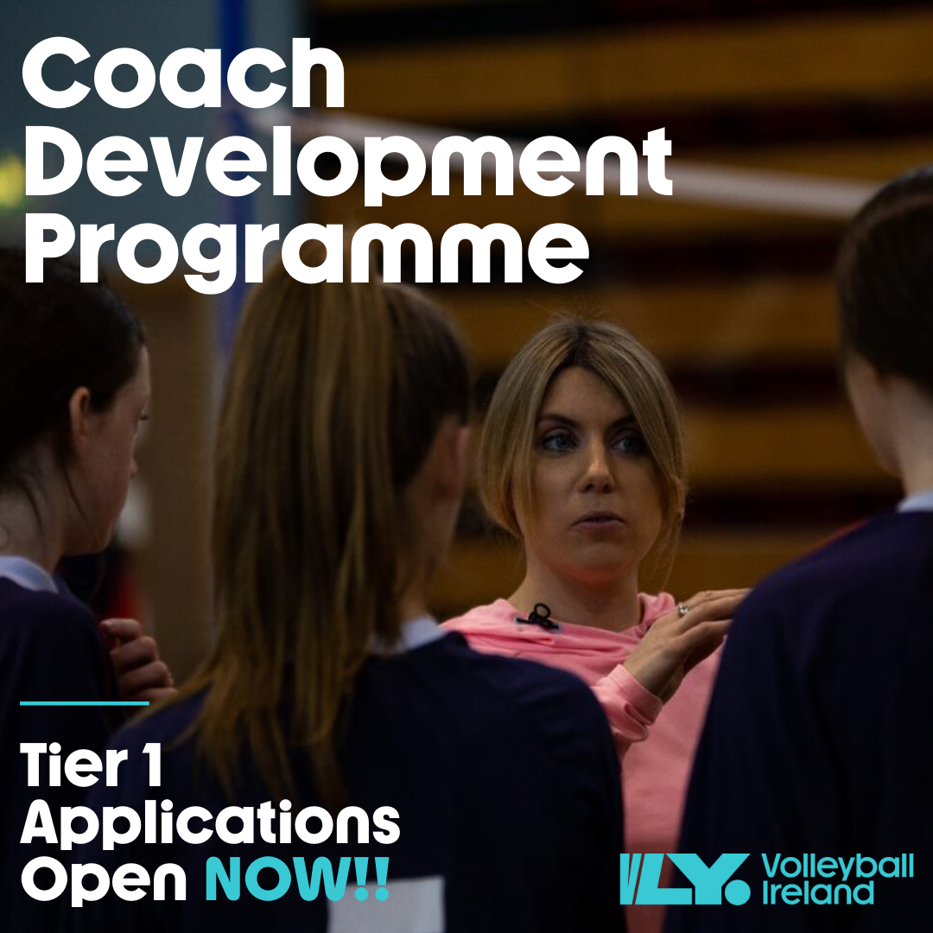

Tier One Programme – New Coaches
The Tier 1 course has one singular goal of supporting new coaches by providing them with additional knowledge and understanding of aspects crucial to a new coach starting out.

Programme Insight
How much is the course? Tier 1 is free of charge.
How long is the course? The course is 5 x one-hour webinars every 2 months beginning March 23rd plus one-half day practical session with an award ceremony in December
Who is the course for? This Tier 1 course targets coaches who typically have less than 2 years’ experience on court or new coaches looking to start out on a coaching pathway.
What time are the webinars? They will take place online through Zoom, 7.00pm-8.00pm
What format will the webinars take? Volleyball Ireland has sought out a number of highly experienced coaches and players within our own country. These presenters will transfer their valuable insight over a one hour presentation and discussion.
Who are the presenters and guest speakers? Presenters include Erica Fatini, Sophie Quinlivan-Nolan, Emma Byrne, Ciara Lowe, Isabelle Smith, Mary Barrett, Jenny King and Jennifer Moret. Guest speakers are TBD
Can I attend just one or two of the sessions? No, this course requires participants to attend all sessions to achieve certification.

What coaching topics will be explored?
Webinar 1 – 23/03  Erica Fatini | Webinar 2 – 25/05  Sophie Quinlivan-Nolan, Emma Byrne, Ciara Lowe & Isabelle Smith | Webinar 3 - 27/07  Mary Barrett | Webinar 28/09  Sport Ireland Tutor TBD | Webinar 5- 30/11  Jenny King
Players on court | A player’s perspective | Injury Prevention | Leadership | Coaches topic pick
Assigning player position to maximize potential | Communication on and off the court | Strength & conditioning for young volleyballers | Building resilience
Training squad drills for collaboration and team development | Leadership on and off the court | Fitness testing | Developing you

Practical Session – December 2021
Jennifer Moret
Basic offence & defence systems
Building team relationships

*Practical session is subject to restrictions and may be moved online. Exact date & location is TBD & dependant on location of course participants.

Tier 1 Application Form
Please complete the application form and return a copy to Conor at cdo@volleyballireland.com. Successful applicants will be notified on March 5th, 2021. Deadline for applications is Monday March 1st - 16:30pm.
Please note Tier 1 is for new coaches. This includes those not currently connected to clubs and those with no coaching experience to date.

Full Name Click or tap here to enter text.

Club / School Click or tap here to enter text.

Please explain briefly why you would like to be part of this programme
Click or tap here to enter text.

