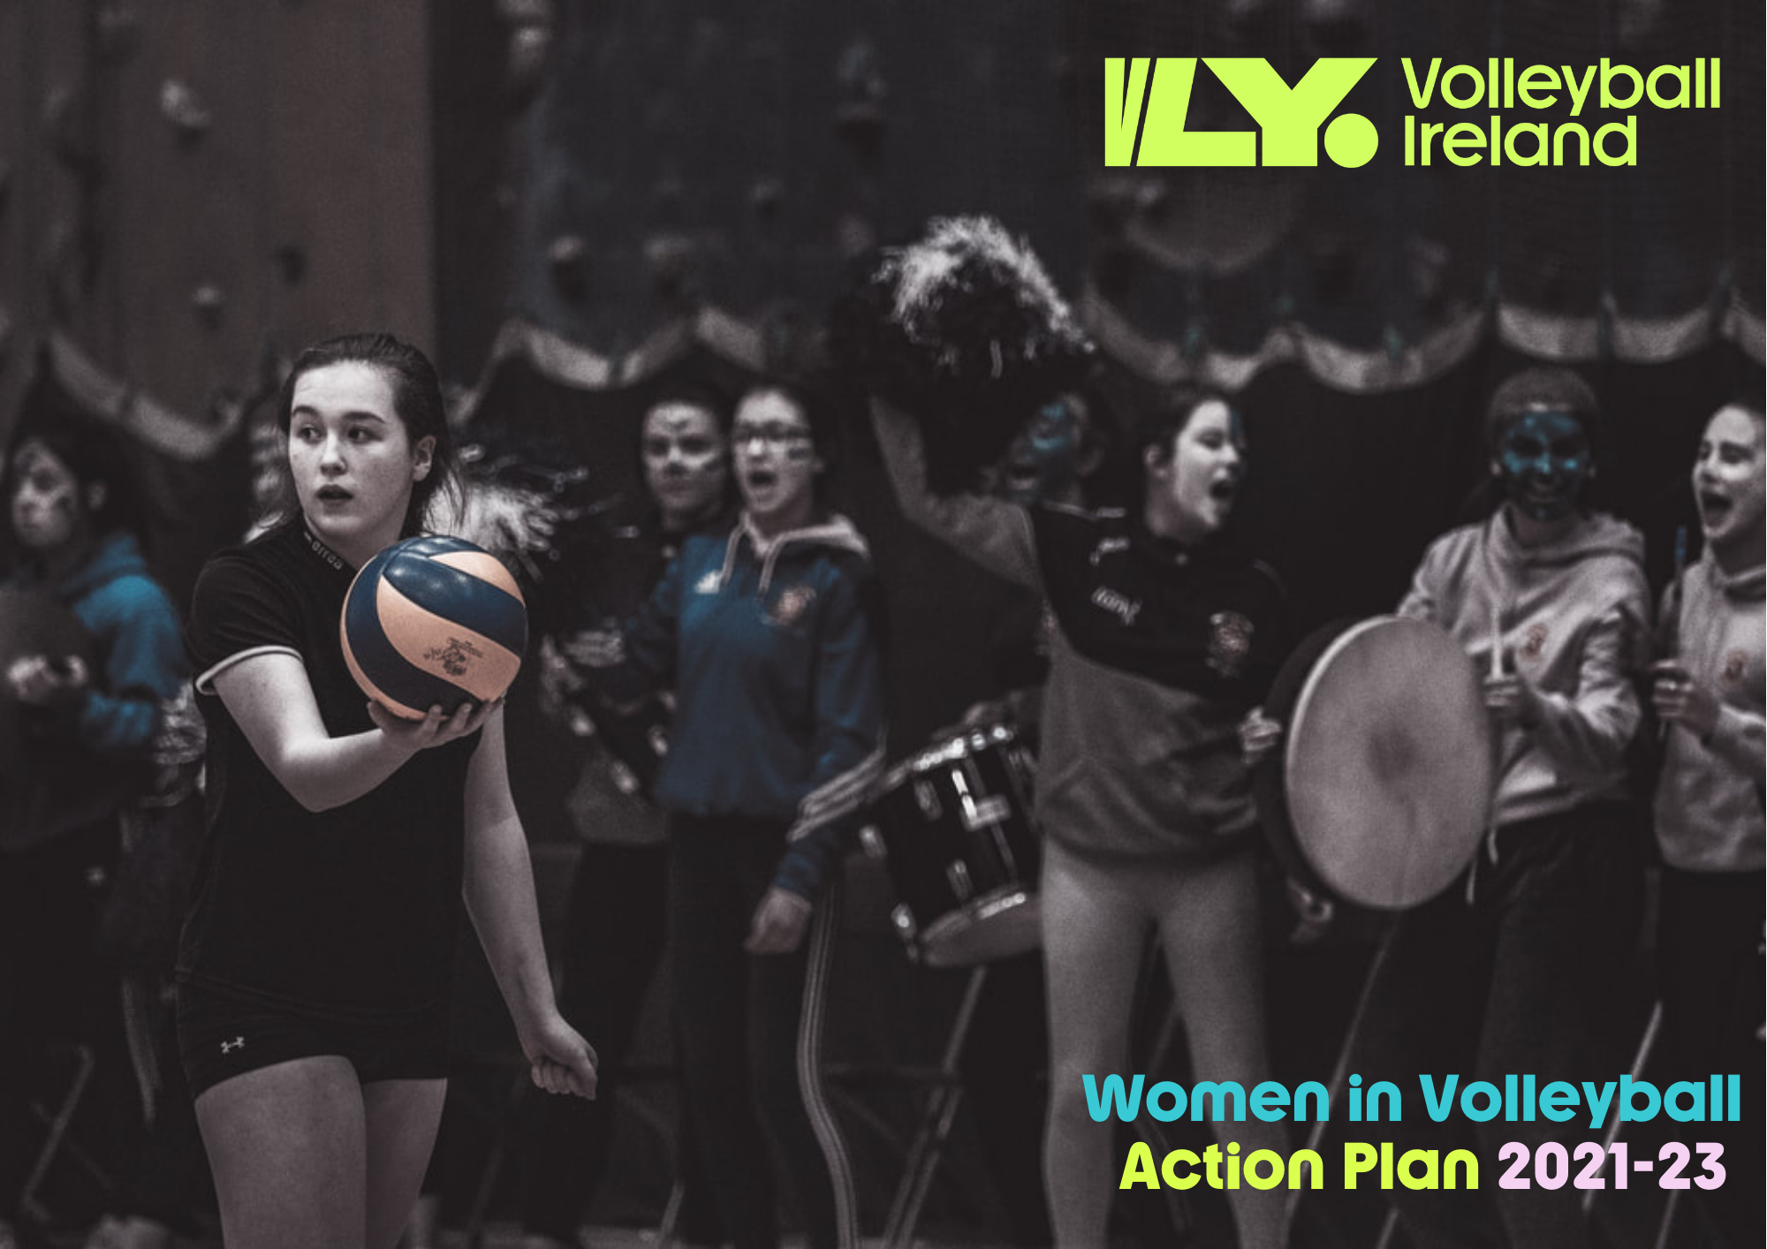

Introduction
This strategic action plan outlines key objectives, milestone aims and a series of actions to increase the representation of females in Volleyball, and to help reduce a number of inequalities that currently exist. The action plan focusses on four key areas, aligning with Sport Ireland’s 2019 Women in Sport Policy; Coaching & Officiating, Active Participation, Leadership & Governance, Visibility.
This document also provides some context in terms of the sport in Ireland at the moment, and outlines in more detail the programmes that will underpin the Action Plan. The plan summarises the current player pathway for girls to progress in the sport.

Volleyball in Ireland 4
Coaching & Officiating 5
Active Participation 6
Leadership & Governance 7
Visibility 8
Programmes 9
Player Pathway & LTPD 12

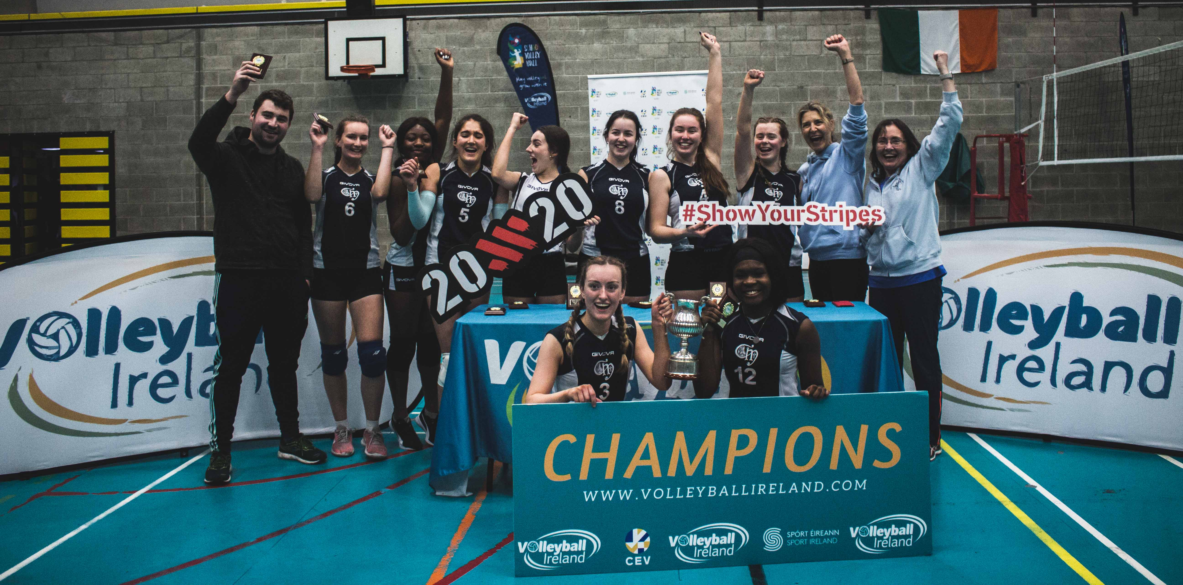

Volleyball in Ireland
Volleyball is one of the few sports in Ireland where female participation exceeds male (61%). As the fifth most participated sport in the world, Volleyball provides a unique opportunity to help reduce the female – male inequalities that exist in Irish sport.
In Ireland, the sport is incredibly multi-cultural with over 70% of licensed players coming from abroad. This gives the community a diverse flavour. Clubs are spread across Ireland with 25 affiliated clubs being represented in a National League and Recreational competitions.
A large schools programme is popular at primary and secondary school level and there is strong activity in Colleges, however the small number of clubs means the demand for participation isn’t being met and more opportunities for club participation are required, especially for juniors.
At a performance level, self funded National teams represent Ireland in both formats of the game with female teams recently competing in u16, u17 & Senior European Championships in both formats of the game.
In recent years a number of programme developments have helped grow the sport including;
- Formation of a Youth National League for Girls & Youth Beach Tour programme
- Creation of a Youth Council
- Delivery of DIVA programme
- Launch of a new gender neutral and youthful brand identity
- Introduction of Long Term Player Development model
Coaching & Officiating
There is a clear inequality between the number of female participants in Volleyball (61%) and the number of licensed female coaches and referees. Recent development work targeting players in the Girls junior national league has significantly increased the number of entry level female referees meaning overall 55% of referees are female. However, there is a clear disparity towards the top end of the referee and coach pathway.
- Only 40% of International, Premier or Division One Referees are female.
- Only 30% of Level one or higher coaches are female.
- Only 39% of total coaches are female.
Comparing these statistics to an overall participation of 61% female suggests a clear inequality.
Objective: Reduce the inequalities between the number of female players and the proportion of female officials, whilst strengthening the pathway to elite Refereeing and Coaching.
Measure: Number of licensed coaches & referee
Milestone Aim: Qualify the first female Irish International Referee.
Key Actions:
Action 1: Develop a Coach Development Programme specifically for female referees and coaches
Action 2: Develop a referee mentor programme & pathway to support female referees progress through the levels
Action 3: Develop a female coaching & referee network
Action 4: Promote high level female coaches & referees as positive role models
Active Participation
Adult Volleyball participation in Ireland has been consistently growing for the last four years (14% per year). However, the number of Irish born players has remained relatively stagnant, with a small drop of 2% to 31% in 2019/20. Whilst the multi-cultural diversity of our membership is to be celebrated (69% are foreign nationals).
Objective: Increase the number of Irish players involved in licensed programmes whilst increasing the overall number of registered recreational volleyball players.
Measure: Number of licensed players across VLY. Competitions & Programmes.
Milestone Aim: Double the number of female recreational volleyball players
Key Actions:
Action 1: Expand the DIVA programme to grow Social Volley initiatives for all age groups
Action 2: Expand the Junior Girls National League Programme adding a new u14 age group competition
Action 3: Launch a new Social Volley Parks League
Action 4: Create an introductory programme for new Beach Volleyball players
Action 5: Develop a youth participation project for young players aged 11-14, creating sustainable school>club links.

Leadership & Governance
Female representation at Leadership & Governance level is something of pride for Volleyball Ireland. The graph below covers the breakdown of Female v Male Directors, Commission & Committee members and Club Secretaries of full member clubs.
- Board: 66% Female
- Commissions: 52% Female
- Club Leaders: 58% Female.
However, only 28% of female leaders within this leadership structure are foreign nationals, which is disproportionate to our participation levels where almost 70% of players are immigrants.
Objective: Increase the number of female foreign nationals taking leadership roles within Volleyball Ireland, whilst celebrating and promoting gender balance within Volleyball.
Measure: Annual Report on Governance.
Milestone Aim: Have female representation at International decision making level.
Key Actions:
Action 1: Deliver a promotional campaign to raise awareness of the impact foreign nationals are having in Volleyball.
Action 2: Provide a programme of leadership and club management training.
Action 3: Nominate Volleyball Ireland representatives for International election.
Action 4: Support potential high level leaders with further training, networking and support
Visibility
A number of initiatives have been developed that have risen to good digital growth with a doubling of social media followers on Volleyball Ireland channels in the last two years. A new weekly newsletter is published to a subscriber list of over 1800 people (up 12% versus October 2020). Whilst Volleyball globally is hugely popular, in Ireland gaining mainstream media attention without a marketing & communications resource or budget is a significant challenge.
Objective: Develop and deliver exciting content that raises the profile of Volleyball across Ireland.
Measure: Social Media Followers increase by 30%.
Milestone Aim: Have a Volleyball flagship match broadcast on mainstream free to air TV.
Key Actions:
Action 1: Employ a digital marketing/comms specialist
Action 2: Develop a partnership with a live stream broadcast company to improve the quality of live stream
Action 3: Deliver a range of promotional activities promoting female leaders in Volleyball
Action 4: Develop an ambassadors programme to create positive peer role models for young people.
Action 5: Facilitate social media and marketing training for club PR officers
Action 6: Develop innovative partnerships that will raise the profile of Volleyball
Key Programmes & Competitions Summary
This chapter outlines the key programmes and competition opportunities that we will deliver to support the actions outlined in the previous sections.
DIVA
This is our flagship WIS programme. The Developing Volleyball Activators programme trains and equips females to establish social volleyball sessions. The WIS funded pilot focussed on developing DIVAs in colleges and university, with great success. This model will be replicated in clubs with a keen focus on the 16-19 age bracket. Our young DIVAs will then help setup social volley sessions for their peers and/or younger age groups. This will drive participation and our DIVAs will naturally become positive role models.
An adults version for community clubs will follow which will provide the first step on the coaching/leadership ladder as well as growing participation.
2021-23 Goals: 24 x College DIVAs, 80 x Teen Leaders, 16 x Club Activators in place: 1,200 social volley players recruited.
Coach Development Programme
The Coach Development Programme is a blended approach to Coach Education, with three different levels. This system ensures all coaches can reach their maximum potential and the learning that the programme covers is appropriate for the experience level of each coach. The learnings are delivered through workshops, assignments and mentoring.
- Tier 1, New Coaches; those who have less than two years coaching experience or players who are considering a transition into coaching.
- Tier 2, Intermediate; Coaches who have been coaching for two years or more.
- Tier 3, Advanced; Coaches who have been involved in Volleyball for several years.
2021-23 Goals; 24 Tier 1 new Coaches, 12 Tier2 & 12 Tier3 female Coaches take part.
Referee Mentor Programme
The Referee Mentor programme recruits 8 x Grade 2 or above female referees and provides mentoring, support and guidance to transition referees through a pathway programme. The programme is led by Volleyball Ireland’s International qualified Referee, and includes practical performance feedback, development planning and attendance at a high level international game. Referees will progress to National Level with at least one referee recommended for International training and qualification.
2021-23 Goals; 8 female referees take part, with 75% progressing to National Grade.
Youth Leagues
The National Girls Youth League was instigated three seasons ago and was the first Youth League programme for some time. Twelve teams currently participate in the u17 age group. This will extend to a regional system from 2021/22, reducing some barriers to participation (travel & time commitment). Over the next three years participation in the League will grow to 22 teams and over 400 u18 girls will compete in Youth Competitions, up from 237 at present.
2021-23 Goals: 22 teams in Youth League, 400+ u18 girls have active player licenses.
Junior Beach Tour
The Junior Beach Tour creates a fun and social tournament for u19s. Launched in 2020, 38 players signed up (29 girls). There are typically between 4-6 tour dates each Summer and training days in the build up. Players gain age weighted national tour ranking points. There is a pathway from the tour to Regional Training Squads and National Team competitions. In time, the Jnr National Tour will be FIVB approved with world ranking points applied.
2021-23 Goals: 50 girls registered for the Junior Tour.

Development Centres
The Regional Development Centre programme provides an opportunity for young players (13-16yrs) to gain additional training and expert coaching in a more advanced environment. In year 1, the Centres will operate in East & West regions with 24 girls in each. The ten year plan is to have 5 regional centres operational. Ireland is bidding to host the 2024 European u19 Championship finals and as such will have automatic qualification to the finals. This is a key programme to ‘ready’ players before that event. Players will be talent ID’d from the regional centres to National Team programmes. This model is replicated on the boys side.
2021-23 Goals: 48 girls participate in East & West centres of development.
Skill Centres
The Skill Centre initiative is a participation programme aimed at 11-14year olds. Volleyball Ireland Skill Events tour the country providing fun environments for players to play volleyball. Effectively the Skill Centres are high energy 1 day camps that promote volleyball as a bright, supportive and positive sport. The production of the events are designed by our Youth Council and activities are led by Teen DIVAs. Music, bright colours and atmosphere make the day memorable and inspire future participation.
2021-23 Goals: 300 children participate in 6 skill centres each year, ave 50 per event.
All Stars
The All Stars is our new youth club support programme. It is modelled on Basketball Australia’s Aussie Hoops and England Cricket’s All Stars programme. It is nationally coordinated and marketed and locally delivered by clubs. It is aimed at children aged 8-14 years olds. Our Teen DIVAs will be trained to deliver activities at All Star events.
2021-23 Goals: 10 clubs host All Stars programmes, with 120 children taking part each year.

Player Pathway: Programme & Competitions
The Volleyball Ireland Programme & Competition pathway highlights opportunities for players throughout their volleyball journey. This section provides some information on player pathway opportunities and gives an overview of our LTPD model for reference.
Starting with free and active play at 0-6years old, players can progress through 2v2, 3v3 Fundamental Volley into 4v4 volleyball and finally into full 6v6 volleyball.
They can do this at club level and in school, moving into new competitions and programmes when they are ready, and with the necessary skills to achieve success and enjoy the sport.
This approach creates a system, structure and pathway.
There are lots of opportunities for participation on the court but also off it with coaching and referee pathways. It is vital that once a player finishes their career they continue to participate in some way, whether that’s through a Masters programme or assisting younger players in the Development League competition. We believe in life long participation in Volleyball, so have created Chair Volley, which is specifically designed for elder adults allowing them to enjoy fun, social and competitive volleyball into their 90s.
The pathway model demonstrates that some programmes are stage specific, such as 2v2 Funda Volley but some straddle various age groups such as the National League Competition.
Performance Pathway
This visual outlines the performance structure that exists across Volleyball, giving a clear pathway from the Skill Centre participation project into the National Team Performance stage. Via, the Development stage. This model is aligned with our LTPD pathway.

LTPD Model Overview
This diagram outlines the Long Term Player Development Model for Volleyball in Ireland.
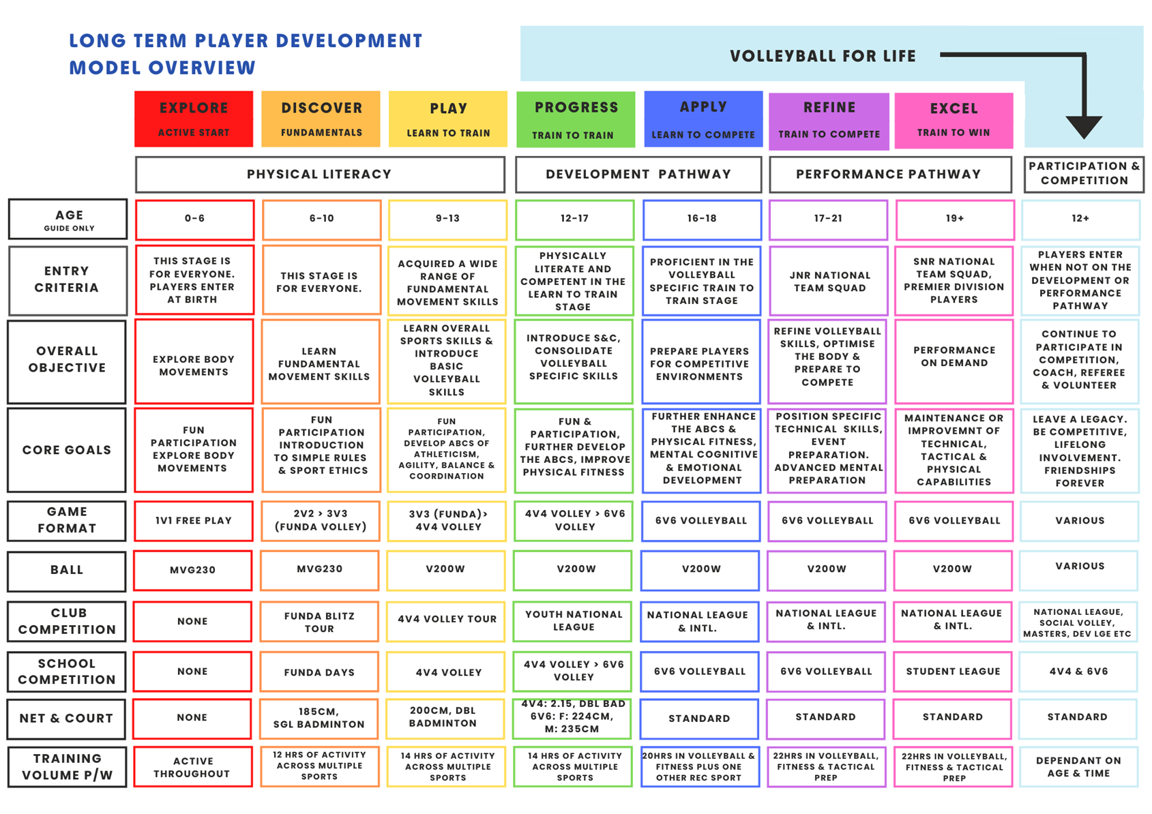
The model is to be used in conjunction with the Volleyball Ireland Coach Education programme and Programme & Competition Model.
The model outlines recommended game formats at each age group that research has shown will have the most benefits for development and retention.
All VLY. Programmes are aligned with this model.

