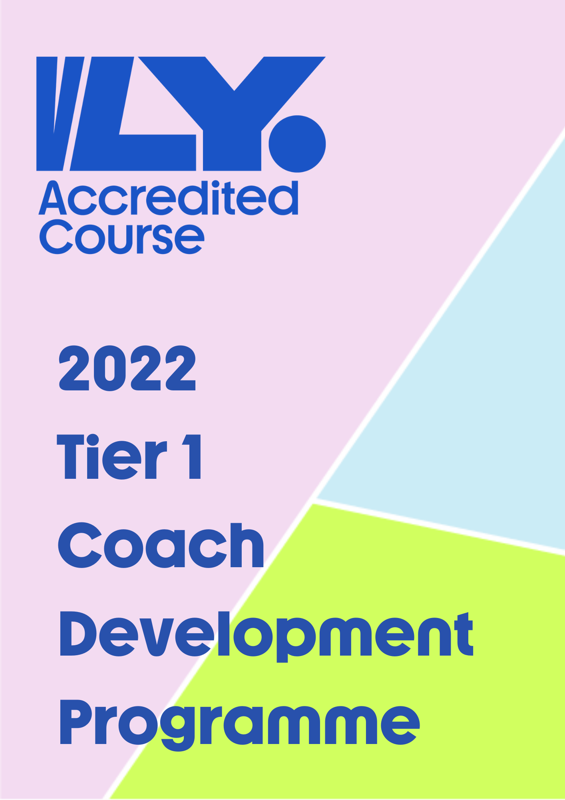

Tier One Programme – New Coaches
The Tier 1 course has one singular goal of supporting new coaches by providing them with additional knowledge and understanding of aspects crucial to a new coach starting out.

Programme Insight
How much is the course? Tier 1 is free of charge.
How long is the course? The course is 4 x one-hour webinars every month. This programme will finish in time to prepare coaches for the upcoming indoor season.
Who is the course for? This Tier 1 course targets coaches who typically have less than 2 years’ experience on court or new coaches looking to start out on a coaching pathway.
What time are the webinars? They will take place online through Zoom, 7.00pm-8.00pm
What format will the webinars take? Volleyball Ireland has sought out a number of highly experienced coaches and players within our own country. These presenters will transfer their valuable insight over a one hour presentation and discussion.
Who are the presenters and guest speakers? Presenters are Declan Ryan, Tom Landers, Patricia Somers & Andrei Molnar
Can I attend just one or two of the sessions? No, this course requires participants to attend all four sessions to achieve certification.

What coaching topics will be explored?
Webinar 1 – 14/06  Declan Ryan | Webinar 2 – 19/07  Tom Landers | Webinar 3 – 15/08  Patricia Somers | Webinar 28/09  Andrei Molnar
Match Protocols | Sports Coaching, what is it? | Preparing and Evaluating | Building Junior Programmes to High Performance
Substitutions. What is the correct procedure? Tactical Substitutes.  Bench & Warm up areas between sets.  Coach responsibilities | Similarities across all sports  Coaching qualities  Understanding player needs | Preparing a training session  Mental preparation  Breaking down a skill and statistics | Realistic targets  Player recruitment  Building pathways  Training methods

All coaches are invited to the 2022 Volleyball Ireland Conference weekend in September/October as an additional opportunity for development.
*Volleyball Ireland conference date and venue TBD

Application Form
Please complete the application form and return a copy to Conor at cdo@volleyballireland.com. Successful applicants will be notified on May 30th, 2022. Deadline for applications is May 27th, 2022

Full Name Click or tap here to enter text.

Club / School Click or tap here to enter text.

Please explain briefly why you would like to be part of this programme
Click or tap here to enter text.

