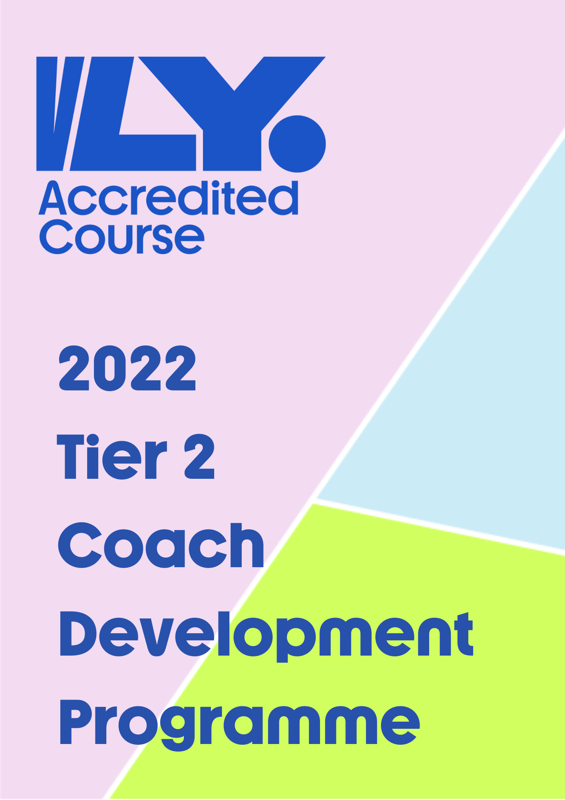

Tier Two Programme – Intermediate Coaches
Coaches are granted private access to either senior or junior National Team head coach sessions to observe, discuss and even challenge methods of training strategies and team management styles.
This tier is particularly attractive for coaches that may be working in the National Youth League and with a minimum of 2-year experience.

Programme Insight
How much is the course? Tier 2 is free of charge. However, all travel and subsistence expenses are borne by the course attendees.
How long is the course? Coaches are expected to attend one weekend training camp to observer both male and female sessions. Attendance at Celtic Nations tournament 2022 is optional for coaches to gain exclusive access to courtside.
Where are the National team trainings?
The Tier 2 programme has targeted the January 2023 training weekend. This date may change depending on International match competitions that are scheduled prior to January.
Do I have to stay overnight?
Attendees can choose to stay or return on Sunday for the 2nd day. Coaches will be staying overnight at each session and therefore additional access and informal learnings may take place during the even
High-Performance Session Breakdown
This Tier 2 programme involves weekend camps with the national teams. The informal style programme will provide coaches with the realities of training camps for national squads in Ireland. This interaction and all access model is widely accepted as a successful approach for coach development.

Coaches can expect from the weekend camp
- observation of tactics, drills, and implementation of technical development during morning and afternoon training sessions.
- debate player management practices
- have extensive opportunities for discussion and question time with NT coaches both during and after sessions while at camp.
- to be tasked in delivering short tasks for the players to complete.
- receive feedback from head coach on those task deliveries.
- Additional match critiquing and analysis during the evening or sit in on national team meetings.

Tier 2 Application Form

Please complete the application form and return a copy to Conor at cdo@volleyballireland.com. Successful applicants will be notified by May 30th 2022. Deadline for applications is May 27th
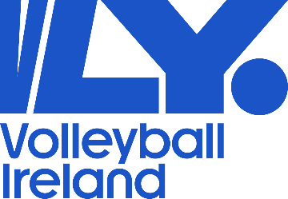

Full Name Click or tap here to enter text.

Club / School Click or tap here to enter text.

Please explain briefly why you would like to be part of this programme
Click or tap here to enter text.

