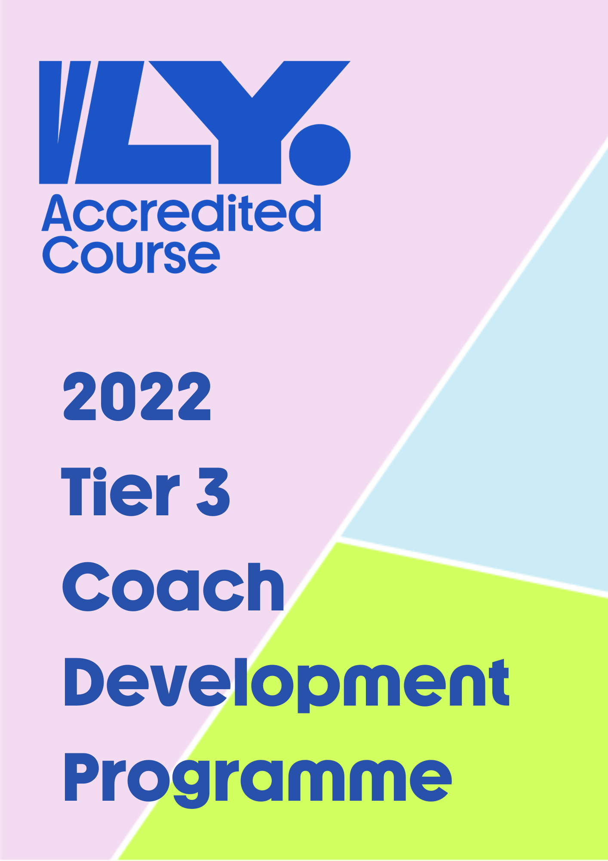

Tier Three Programme – Advanced Coaches
Our Tier 3 programme is supported by internationally recognised coaches. This programme is designed for our coaches to work, learn and develop alongside some of the world’s top coaches and experts within the sport.

Programme Insight
How much is the course? Tier 3 is free of charge. However, any travel or subsistence expenses are borne by the course attendees.
How long is the course?
Coaches will be expected to attend 40 hours of sessions over a two part programme. Volleyball Ireland have identified Bogdan Tanase to conduct Part 1 of the programme in early June.
Part 2 of the three tier programme is a coach exchange to a professional club in Europe. Details are currently being finalised. Coaches will be expected to pay a percentage of travel and accommodation costs.

What topics will be covered?
Please see the following page for a breakdown of topics that have been identified as areas for advanced coaches to develop their skills. There will also be an opportunity for the group to engage in discussions with the coaches on areas they feel would develop themselves and Irish volleyball.

Are there any follow ups?
Volleyball Ireland would ask that the group share their knowledge learned within their clubs to fellow coaches. Secondly, to support Volleyball Ireland in delivering any workshops relating to the specific topics covered in Tier 3.

Tier 3 Coach Part 1, June 4th & 5th Topics

- Building the setter
- Defence tactics for left wing
- Defence systems
- Block tactics
- Blocking in a defence system

*Bogdan is willing to discuss additional topics coaches wish to bring up during the Part 1 session

Tier 3 Application Form
Please complete the application form and return a copy to Conor at cdo@volleyballireland.com. Successful applicants will be notified by May 30th, 2022. Deadline for applications is May 27th

Full Name Click or tap here to enter text.

Club / School Click or tap here to enter text.

Please explain briefly why you would like to be part of this programme
Click or tap here to enter text.

