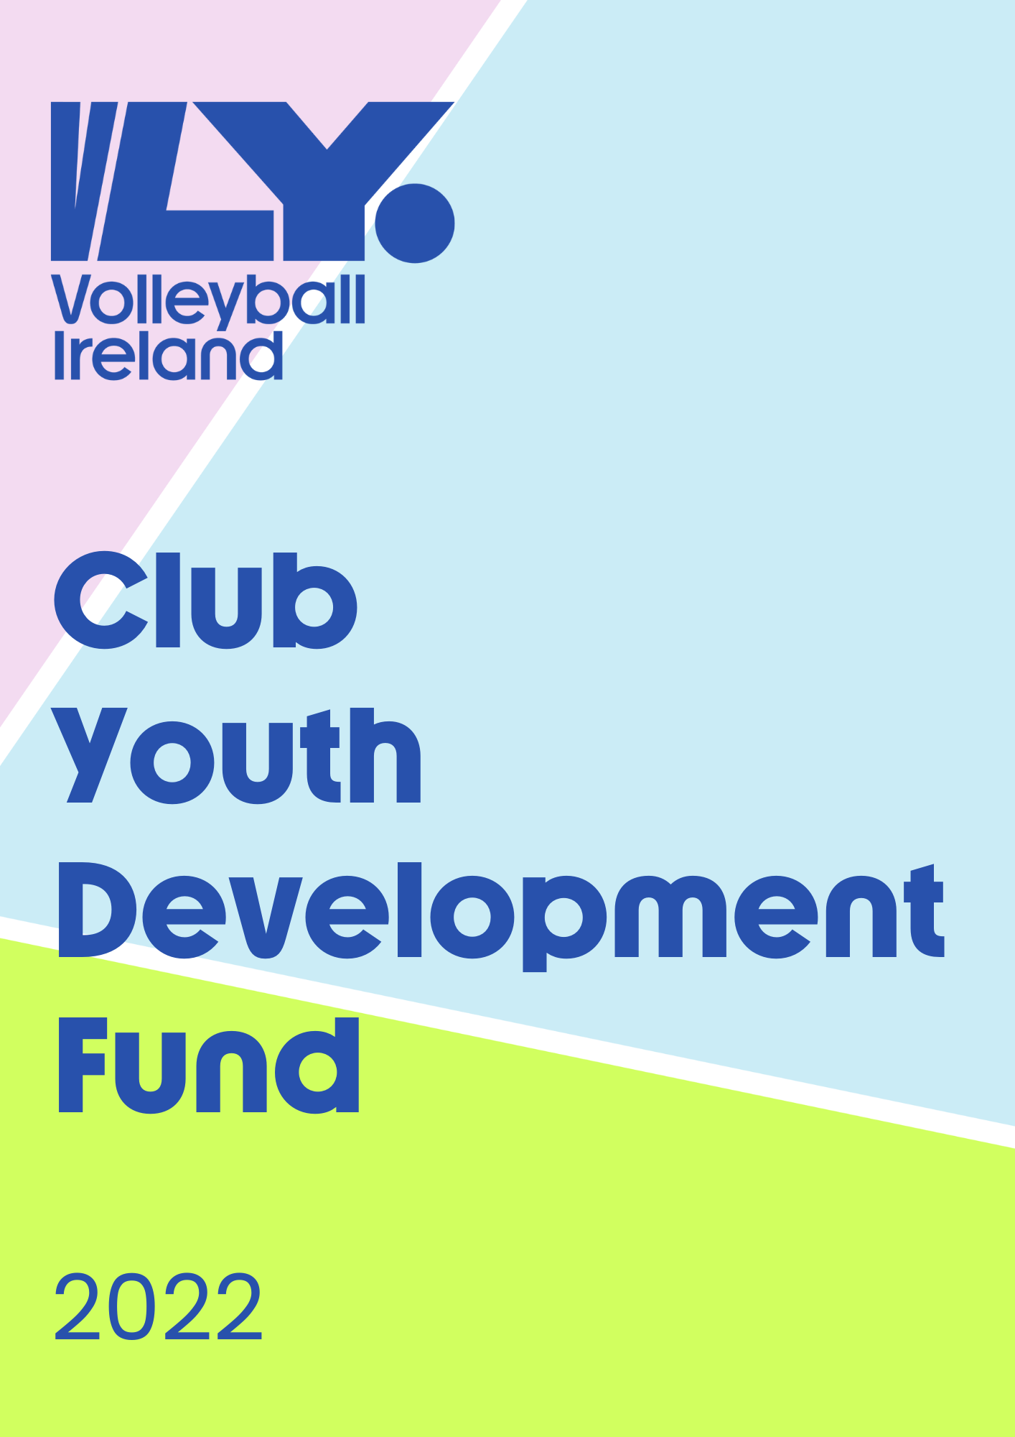

- Introduction
Volleyball Ireland, with support from Sport Ireland have announced a new Youth Club Development fund to help support clubs that are operating youth sections.
Clubs are offered the opportunity to apply for between €500 and €7,500 for projects that will demonstrate and impact growth of volleyball amongst children aged 9-14 years old.
- Process
Clubs apply to VLY. by providing a development plan outlining cost, timelines and all impacts from the short, medium and long term goals.
A youth development plan template is provided here to assist clubs with the process.
The youth club development fund will be open for submissions in two distinct application windows. Clubs may apply during both windows.
1st application deadline 04/09/2022 (awarded 16/09/22)
2nd application deadline 04/11/2022 (awarded 16/11/22)
- Details
- The funds do not need match funding or a percentage contribution from clubs.
- Clubs can invest the funding on coaching, equipment, programmes or facility upgrades that will specifically benefit youth players.
- 75% of the funds will be distributed after an application approval by an independent judging panel.
- The remaining 25% is released upon completion of your club’s end of year report.
- Each club that receives a Youth Development grant must appoint a Director of Youth Development or Youth Head Coach. This person will be the main contact with Volleyball Ireland for this project and will be expected to disseminate information to the clubs’ committee and other youth coaches within the club.
- The Youth Director or Youth Head Coach will attend at least three meetings per year with other people taking on this role. These meetings are an opportunity for directors to meet, discuss and learn from each other to bring back information and ideas to enhance their own clubs’ development and youth volleyball in general.

- Communications & Important Dates
All queries can be answered by Development Manager Conor Flood via cdo@volleyballireland.com
- Information session: Tuesday 30th August 2022. Registration link -
https://us02web.zoom.us/meeting/register/tZMlcuuqrDstGtGK2yMH6uZdlWzQ8obTV4ne
- Deadline for applications: A1- September 4th & A2- November 4th
- Awarding of grants: A1- September 16th & A2- November 16th
- Deadline for end of year report: May 1st

- Key Points for your Application
Ideally, your youth development plan should:
- Be linked to the overall ‘Vision’ for the club
- Think about key short, medium and longer term goals
- Highlight projected actions, finances and timescales to achieve these goals
- Allow for a review of progress and outcomes throughout the year

Club Logo

[Club Name]

Youth Development Plan
[Year From – Year to]

VLY. Youth Development Funding Application

- Key Information
Club name
Youth Director or Youth Head Coach
Contact info email/phone
Amount you’re applying for (Max €7,500)
Youth membership numbers currently | Girls aged 6-8:  Boys aged 6-8:  Girls aged 9-14:  Boys aged 9-14:  Girls aged 15-17:  Boys aged 15-17:  Total players under 18:
Youth Coaches currently | No formal qualifications:  Foundation Level:  Level 1:  Other (FIVB):  Total youth coaches:
- The Current Situation:
From a Youth Development context, please provide an overview of what your club provides for young players. Please consider the number of players and coaches that you have that are active, the quality of your facilities and the types of coaching equipment that you have available.
Max 250 words.

- SWOT ANALYSIS
This is a fantastic tool that will get your Youth Committee thinking about the opportunities that this funding and a plan can present.
Strengths: |  | Weaknesses:
Opportunities: |  | Threats:
- Overall Goal: What does Success look like for your Youth Section:
Please describe what the impact of the funding will be in your Youth Section. What will this funding allow you to do?
Max 250 words.

- Your Youth Coaching Values:
What are the key messages you want your coaches to live by?

- Please outline the objectives that will help you achieve your goal.
The objectives should be measurable i.e. Grow Youth Club membership to 100 players or Purchase 1x spiking technique machie to aid player development.
Objectives  (What measurables are you looking to achieve) | Who  (Identify within the club who will take on this action) | When  (timescale)
Appoint a Head of Youth Development to oversee the delivery of this plan. | Children’s Officer | By end Aug 20XX

7. Outputs: These are easy to measure results of the impact of your plan.
I.e. 100 children participating in the youth programme
5.1 | 100 children aged 9-14 participating regularly in the Club
5.2
5.3
5.4
5.5

8. Budget:
Item | Total Cost | Description
Coaching Time | 750.00 | Total of 300hrs of Coaching time from 3 coaches across the season @25ph

