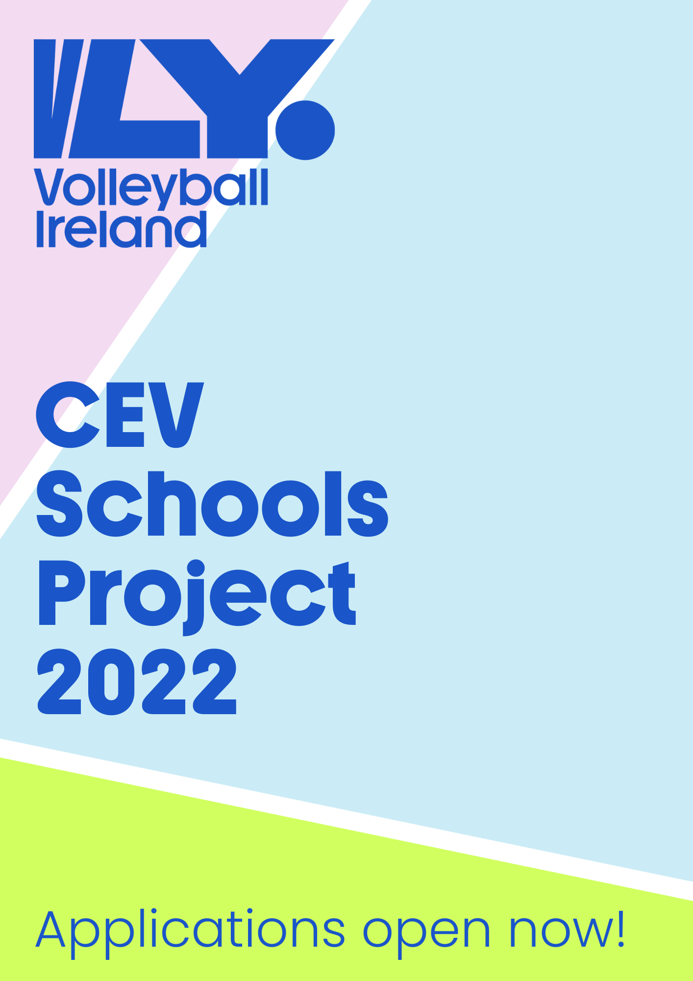

CEV Schools Project 2022
As part of Volleyball Ireland’s commitment to supporting the club game and the further development of the sport, we have once again partnered up with the Confederation Europeene de Volleyball (CEV) to launch another year of CEV schools’ project.
Introduction:
The School’s Project has returned for a second time in 2022! VLY have partnered with our European federation (CEV) to bring the joy of volleyball to more schools and young players around Ireland.
- Equipment for schools including Mikasa soft touch volleyballs and net band
- Equipment for clubs including training balls.
- Club led teacher & student training session on week 1
- Official Volleyball Ireland partner school accreditation
- An introduction to volleyball programme overview
- Teacher resources including lesson plans and coaching support
- Internal school blitz
- All players advancing to club trainings after the School’s Project completion can avail of our exciting new PLAY VOLLEY programme.
Volleyball Ireland is supporting our member clubs through identifying and aiding two local feeder schools and clubs with equipment and resources. The project will create for children the opportunity to progress from schools to clubs within their areas while also strengthening club/school bonds
How it works:
- Clubs apply to join the programme through the application below. For further details or information please contact project lead coordinator Conor Flood cdo@volleyballireland.com 0870997659.
- The project lead and clubs will communicate together to identify potential coaches that may act as the link between schools and club.
- The club and project lead will work to recruit two schools located in close proximity to the club. The main target age is 6-10yrs and 9-13yrs.
- The local club visit the school and provide an introductory session for pupils within the target age range. Participating teachers will be observing and supplied with resources in line with our new LTPD model.
- Mikasa training balls are provided to each participating school and club.
- Each school runs a 4-6 week Volleyball programme (ideally supported by the Club Coach). At the end of the activity, each school participates in a fun internal blitz.
- At the completion of the school’s programme the local club will initiate the next stage- PLAY VOLLEY. This is designed for the students to continue their development in a club setting. Club coaches will be provided with a training programme that meets the needs of children in the Learn to Train development stage.
- Throughout the programme the club and school should work together to setup a link and encourage the students to club nights into the future.
- The Play Volley programme is subsided by VLY and each student will receive a T-Shirt with club name and training ball at a reduced fee of €15 when they sign up through their local club memberships.

Please note; any club that wishes to participate in the CEV Schools Project must have clear evidence that all coaches involved in the youth section are Garda Vetted, and that the club has a Designated Liaison Person and Children’s Officer appointed. If successful in their application, all clubs must provide a copy of their Child Safety Statement and Risk Assessment (as per Children’s First Act, 2015).
Timelines:
We are opening applications for clubs to apply immediately. The closing date for all clubs is October 28th, 4pm

Programme overview-
Full support and session plans available for school & club.

Step 1 – Sample School Itinerary – FUNDA VOLLEY- Focus on ABC’s for volleyball movements
Week 1 | Club led session
Week 2 | Teacher led session
Week 3 | Teacher led session
Week 4 | Teacher led session
Week 5 | Internal Blitz Day

Step 2 – Join your local club- Club Itinerary - 4v4 VOLLEY – Focus on volleyball specific skill introduction
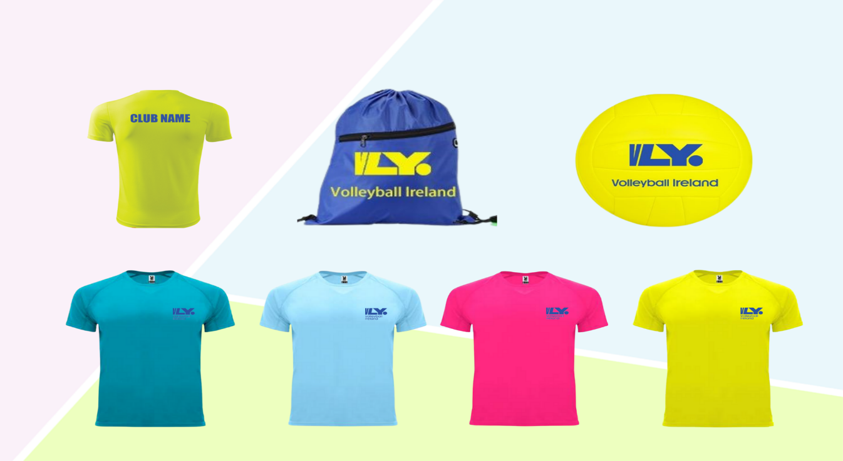

Application Form| CEV Schools Project
The Volleyball Ireland CEV Schools Project aims to raise participation in both school and club Volleyball. Each Club that applies to join the programme agrees to establish a formal school-club link with local primary and/or post primary schools.

Please ensure this application is completely fully and returned with necessary attachments to Conor cdo@volleyballireland.com before October 28th, 2022

Club Name
Club Secretary
Contact Number
Contact Email
Club Designated Liaison Person
Garda Vetting Validation Officer
Club Children’s Officer
Club Address
Does your club have a youth section already?
If yes, please describe current youth activity and/or plans for 202/23
How many active youth playing members does your club have?

Signed Date

____________________________________ __________________________________

