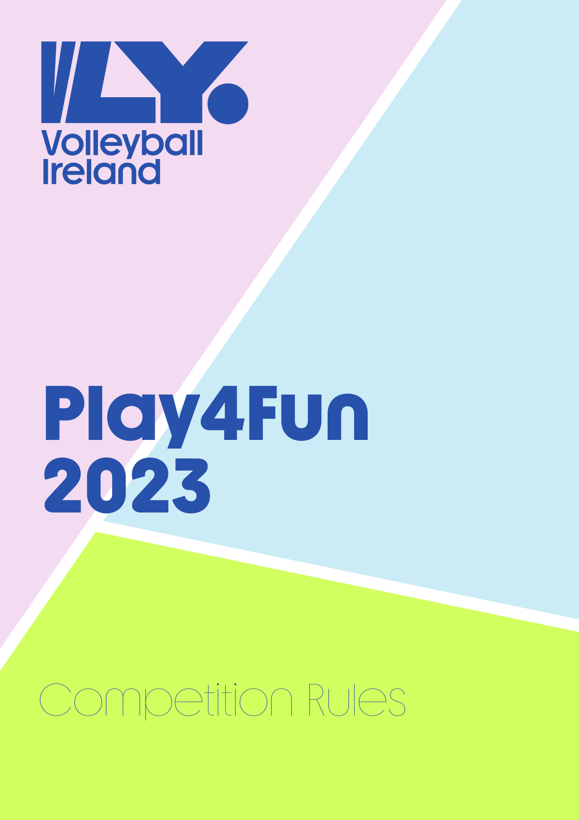

Play4Fun 2023
Play4Fun is a series of non-competitive matches for beginners and social volley groups up to an intermediate level. The aim of this initiative is to connect social volley groups and to offer everybody the opportunity to experience and enjoy volleyball matches in a relaxed and fun environment, without the hassle of strict competition calendar.
1 | Registration
1.1 | A team entry fee must also be paid to enter the competition (€25 per team). Register your team here. Included in the competition fee, each player registered in the competing team will receive a competition t-shirt.
1.2 | New teams can register for competition at any time, as the registrations will be continuously open. They will be inserted in the pools for the following round.  Deadlines to register:  - To enter round 1: January 11th 2023  - To enter round 2: March 16th  - To enter round 3: TBC
1.3 | Each team participating must be part of a League or Associate Club affiliated with Volleyball Ireland. If you are a social group, you can become an Associate Club by filling in the affiliation form and paying the affiliation fee (25€).
2 | Competition structure
2.1 | Each team will be assigned to a pool of 3 or 4 teams. Each pool defines a day of competition and meets to play against each other in a one day mini blitz before a given deadline. Once all results are in, new pools will be created and 2nd round can be played.  Deadlines (TBC)  - Round 1: March 19th  - Round 2 TBC  A final day will be organised by Volleyball Ireland for all participating teams to come together and play again around the end of April.
3 | Playing Rules
3.1 | All matches will be played in accordance with the FIVB rules of the game as adapted by the VI.
3.2 | All matches in Round 1 and 2 are best of 3 sets -25, 25, 15. Each set must have a two point margin.
3.3 | Each team must have minimum 3 women playing on court at all times.
3.4 | Substitutions can take place at any stage during matches and do not need to be recorded.
3.5 | Rotation slips will not be requested.
3.6 | Net Height will be 2.35m.
3.7 | Teams should wear appropriate attire to play. We encourage the use of uniforms or jerseys with numbers to help referees, but not essential.
4 | Venue and schedule
4.1 | Matches will be played in mini blitzes organised by teams themselves. Once the pools are released, teams of each pool must get in contact with each other to decide which venue is most suitable to welcome everybody for playing and must pick a date that suits all teams.
4.2 | Competition can be run on weekdays or weekends. Two matches can be played at the same time if the venue has two cross courts and teams are in agreement to play with reduced service space.
4.3 | The playing hall must be covered with public liability insurance by the hosting club. For safety reasons, we strongly suggest that the hosting hall is equipped with floor fixed posts or equivalent.
4.4 | Volleyball Ireland will do all possible to create pools with teams geographically close and assist in locating suitable venues, but some more distance may be required in round 2 depending on the teams that entered the competition.
5 | Costs
5.1 | Home teams will split the cost of the hall among all teams participating.
5.2 | The playing hall must be covered with public liability insurance by the hosting club.
5.3 | All teams are welcome (suggested) to bring and share food throughout the day, to create a sense of community and fellowship among teams.
6 | Players
6.1 | All players must hold a Volleyball Ireland Non-League Membership (€15). This membership includes a personal accident insurance coverage that will cover players also during trainings.
6.2 | Players with National League memberships won’t be allowed to play in this competition.
6.3 | A team players list will be requested by VLY before the weekend of the match on which players registration number must be recorded. Each team can present a max of 12 players. Any team playing an illegal or unregistered player will not be allowed to proceed with the competition.
6.4 | Minimum age for playing: 18 years old.
6.5 | No maximum age for playing is defined.
6.6 | Players cannot play on different teams within the same season.
7 | Referees
7.1 | All matches will be refereed by a representative of a third team. Each team will be requested to either bring an additional capable person for refereeing (if tow courts are playing at the same time), or a non playing team will propose one of their players for refereeing. The referee does not need to be licenced, but to be capable or refereeing, with good knowledge of rules.
7.2 | A 2nd referee is optional but very much preferred if the number of people present can accommodate this.
8 | Results
8.1 | The team organiser must contact the competition coordinator – Amanda amanda@volleyballireland.com – with the results of matches by the round deadline (see rule 2.1), with a picture or scan of every scoresheet.
8.2 | A simplified scoresheet will be provided by Volleyball Ireland.
9 | Protests and misconduct
9.1 | Any protest should be submitted, in writing, by the team representative to the competition coordinator. This will be reviewed and ruled within 3 working days.
9.2 | Teams shall be held responsible for any misconduct or damage caused by their player(s), coaches or supporters.

Event: Play4Fun
Team:
Players info:
 | Surname | Name | Date of birth | Tshirt size
1.
2.
3.
4.
5.
6.
7.
8.
9.
10.
11.
12.

Date
Coach/captain signature

