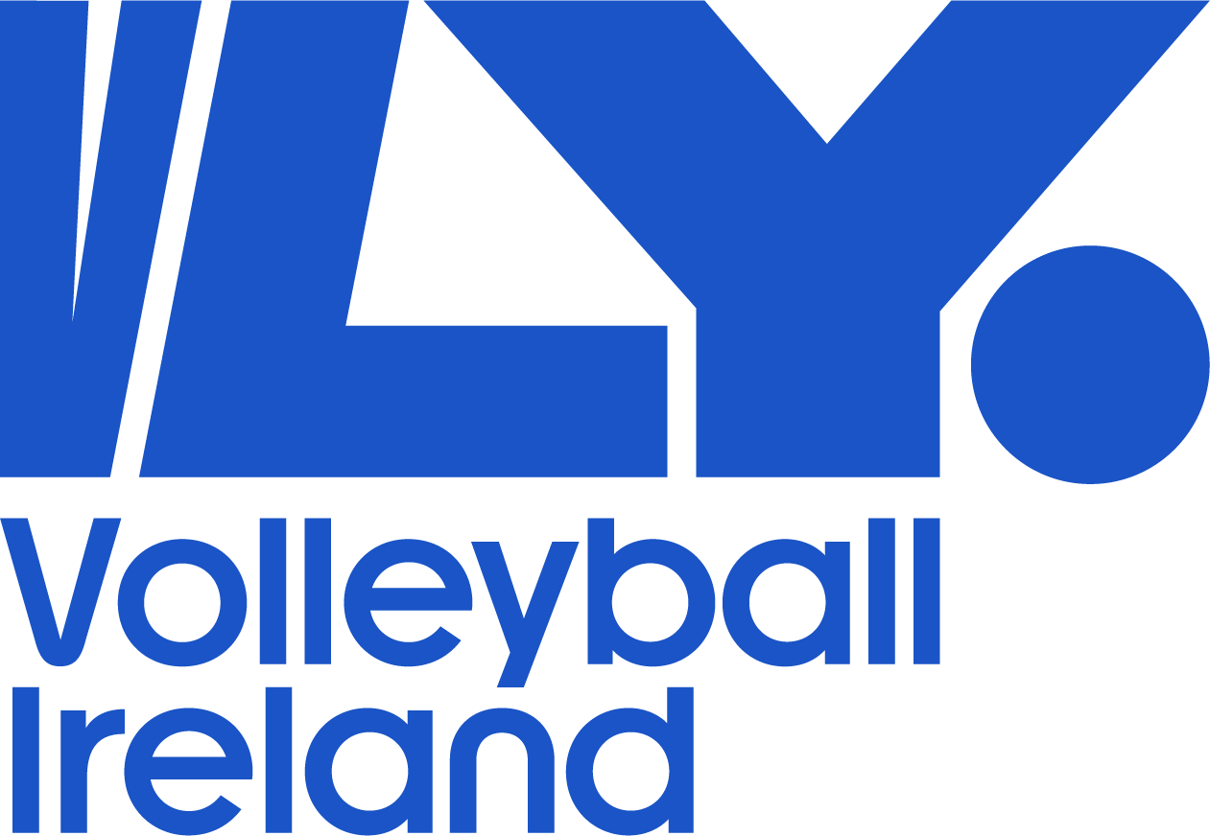

Volleyball Ireland
Coaching Policy
2023-24

Volleyball Ireland Coaching Policy & Licensing 2023-24

Aim

Volleyball Ireland Coaching Commission is committed to the development of the Lifelong Involvement in Sport and Physical Activity of Volleyball, with continue development in the role of Coaching Volleyball.

- Objectives

  - Annual coaching courses

  - Coaching Pathways in line with LTPD programme

  - Host Coaching Seminars/Workshops nationwide, as part of coaches Continuous Profession Development (CPD).

  - Support Coaches that are registered within Volleyball Ireland, who are coaching teams in the National Leagues and at High performance level.

  - Review of Volleyball Ireland Coaching Curriculum, aligning with Coaching Ireland requirements.

- VLY Coach Developers 2023

Des Currivan - (Coaching Ireland Assessor)
Conor Flood ( coaching Ireland Assessor)
Declan Ryan
Michelle Tanner
Jenny King
Erica Fatini
Robert Wypiorczyk

- Coach requirements

  - All coaches need to be registered and have attained a core qualification with Volleyball Ireland to coach a team in the National Leagues- Premier, Division 1, Division 2, Development League and Youth National leagues.
  - Upcoming changes 2024-25 All division 1 & premier league coaches must hold a level 1 qualification.
2025-26 All premier league coaches must hold a level 2 qualification.
  - Coaches can obtain core qualifications through Volleyball Ireland annual coaching courses.
Foundation Course, Cost €50 adults - €45 students/unwaged Level One Course, Cost €150 adults - €140 students/unwaged

- Registration

  - Coach licences run calendar year September 1st – August 31st
  - Participants on a VLY core coaching course off season receive one year’s free licence for the upcoming year or if taking part on a mid-season course for the remainder of that season only. Those taking course during the summer will be provided a free licence for the following season.
  - Registrations can be completed through Go Membership
  - Coach licence €20
  - Anyone coaching u18 must have safeguarding Level 1 and Garda vetting completed before they can register for a licence.

To find out more on coaching courses and Safeguarding/vetting please visit our
website www.volleyballireland.com

- Licence Renewal

5.1 All coaches renewing a licence must complete a minimum of 120 CPD points within the previous 3 years. Evidence of certificates/ attendance must be uploaded to Go membership or approved by the Education & Training commission.
Please see below for a sample on points and courses.

  - Points sample chart

CEV, FIVB core coaching courses | 120 points
Three Tier Coach Development Programme  VI core Foundation or Level 1 course | 80 points
VI & club run workshops / courses | (Points allocated by E&T pre course)  Guide of approx. 40 points per course
All external (related) coaching courses / workshops. I.e but not limited to First aid, nutrition, fitness, | Up to 30 points (on receipt of certification or proof of attendance/participation. Point discretion agreed by the E&T Commission)

- Expired Licences

6.1 Coach licences that have expired 5 years or more will need to re do the core coaching course to retain a VI coaching licence. Previous Foundation coaches must re do the Foundation course. Previous Level 1 coaches must re do the Level 1 course.

- Oversees licence transfer

7.1 To register as a coach with Volleyball Ireland, except for coaches with FIVB grades (please see the bottom of the page), you must be given a Volleyball Ireland coaching grade.

7.2 You can gain a Volleyball Ireland coaching grade in two ways:

- By attending a Foundation Level or Level 1 Volleyball Ireland coaching course
- Or by sending in evidence of holding an overseas coaching qualification and being given an equivalent Volleyball Ireland coaching grade
- To be given a Volleyball Ireland coaching grade you will need to send the following information to the Volleyball Ireland Coaching Commission email: educationtraining@volleyballireland.com

- A copy of your relevant volleyball coaching qualifications (hard or electronic), which should include the following information:
- The name of the awarding body/national federation
- The level of the course
- The date the course was passed
- A copy of the course syllabus (breakdown of the hours, modules and content covered) with an accompanying English translation
- One coaching session then observed by a Coach Developer

When you have provided us with this information, along with one training session observed, Volleyball Ireland will assess your qualifications against the syllabus for Volleyball Ireland qualifications.
We will then inform you of your equivalent qualification level and how you can register as a coach.
For coaches with FIVB qualifications, you will only need to send in a copy of your certificate and your FIVB grade will be printed on your coach registration card after you have registered as a coach with Volleyball Ireland.

If you have any further questions or queries, please contact educationtraining@volleyballireland.com

