CEV Schools Project 2023
As part of Volleyball Ireland’s commitment to supporting the club game and the further development of the sport, we have once again partnered up with the Confederation European de Volleyball (CEV) to launch another year of CEV schools’ project.

How it works:
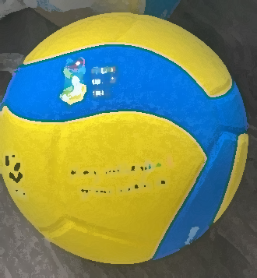
The School’s Project has returned for a third time in 2023! VLY have partnered with our European federation (CEV) to bring the joy of volleyball to more schools and young players around Ireland.
- Equipment for schools including 10 training volleyballs
and net band.
- Teacher educational 2-hour workshop
- Official Volleyball Ireland partner school accreditation
- An introduction to volleyball programme overview
- Teacher resources including lesson plans and coaching support.
- FUN school blitz competition against Northern Ireland Schools
Volleyball Ireland is supporting schools with equipment and resources. The project will create for children the opportunity to learn volleyball in a fun and relaxed school environment.

Programme Overview:
- Schools apply to join the programme for 2023. €25 Affiliation fee
- Teachers attend a 2 hour introduction to volleyball workshop
- Teachers deliver a 4 week training programme within schools.
- School enters FUN Blitz competition against Northern Ireland Schools in December. (Venue Newry TBD)

Contact project lead coordinator Lina linad@volleyballireland.com 0851691850.
Timelines:
We are opening applications for clubs to apply immediately. The closing date for all clubs is October 30th, 4pm
Week 1  start 6th Nov | Teacher led session
Week 2 | Teacher led session
Week 3 | Teacher led session
Week 4 | Teacher led session
December | Blitz Day competition against NIR Schools
Notes: * The main target age is 5th and 6th classes pupils.
* Maximum of 16 schools

Application Form| CEV Schools Project
The Volleyball Ireland CEV Schools Project aims to raise participation in school Volleyball. Each School that applies to join the programme agrees to establish a formal school-club link with local primary and/or post primary schools.

Please ensure this application is completely fully and returned with necessary attachments to Lina linad@volleyballireland.com before October 30th, 2023

School Name
Contact Number
Contact Email
School Address
Does your school have a sports hall?
Does your school have a volleyball equipment already?

Signed Date
____________________________________ __________________________________

