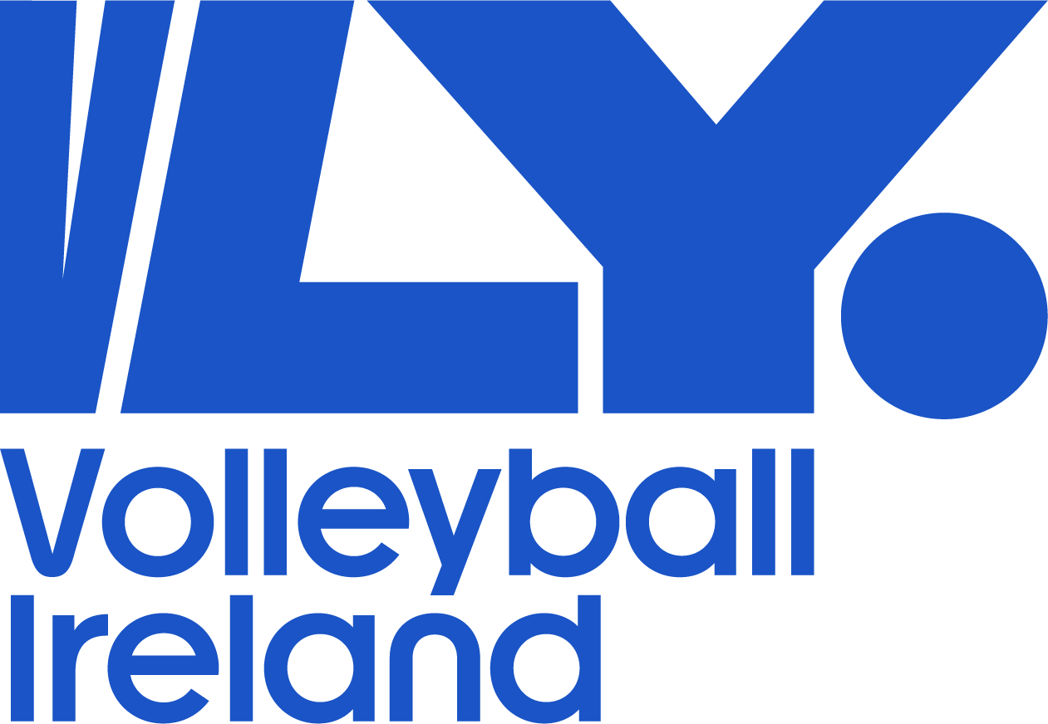

Volleyball Ireland
Coaching Policy
2025-26

Volleyball Ireland Coaching Policy & Licensing 2025-26

Aim

Volleyball Ireland Education and Training Commission is committed to the development of the Lifelong Involvement in Sport and Physical Activity of Volleyball, with continue development in the role of Coaching Volleyball.

- Objectives

  - Annual coaching courses

  - Coaching Pathways in line with LTPD programme

  - Host Coaching Seminars/Workshops nationwide, as part of coaches Continuous Profession Development (CPD).

  - Support Coaches that are registered within Volleyball Ireland, who are coaching teams in the National Leagues and at High performance level.

  - Review of Volleyball Ireland Coaching Curriculum, aligning with Coaching Ireland requirements.

- VLY Coach Developers 2025-26

Des Currivan - (Coaching Ireland Assessor)
Conor Flood (Coaching Ireland Assessor)
Michelle Tanner (Coaching Ireland Assessor)
Declan Ryan
Jenny King
Erica Fatini
Matt Hanlon
Jeff King
Arnolda Stankaitiene

- Coach requirements

  - All coaches need to be registered and have attained a core qualification with Volleyball Ireland to coach a team in the National Leagues- Premier, Division 1, Division 2, Development League and Youth National leagues.
  - All Division 1 & Premier league coaches must hold a Level 1 or equivalent qualification. Youth leagues – Divisions 2 must hold a foundation level or equivalent
  - Coaches can obtain core qualifications through Volleyball Ireland annual coaching courses.
Foundation Course, Cost €60 & Level One Course, Cost €100

- Registration

  - Coach licences run calendar year September 1st – August 31st
  - Participants on a VLY core coaching course off season receive one year’s free licence for the upcoming year or if taking part on a mid-season course for the remainder of that season only. Those taking course during the summer will be provided a free licence for the following season.
  - Registrations can be completed through Go Membership
  - Coach licence €20
  - Anyone coaching u18 must have Safeguarding Level 1 and Garda vetting completed before they can register for a licence.

To find out more on coaching courses and Safeguarding/vetting please visit our
website www.volleyballireland.com

- Expired Licences

5.1 Coach licences that have expired 5 years or more will need to re do the core coaching course to retain a VLY coaching licence. Previous Foundation coaches must re do the Foundation course. Previous Level 1 coaches must re do the Level 1 course.

- Oversees licence transfer

6.1 To register as a coach with Volleyball Ireland, except for coaches with FIVB grades (please see the bottom of the page), you must be given a Volleyball Ireland coaching grade.

6.2 You can gain a Volleyball Ireland coaching grade in two ways:

- By attending a Foundation Level or Level 1 Volleyball Ireland coaching course
- Or by sending in evidence of holding an overseas coaching qualification and being given an equivalent Volleyball Ireland coaching grade
- To be given a Volleyball Ireland coaching grade you will need to send the following information to the Volleyball Ireland Coaching Commission email: educationtraining@volleyballireland.com

- A copy of your relevant volleyball coaching qualifications (hard or electronic), which should include the following information:
- The name of the awarding body/national federation
- The level of the course
- The date the course was passed
- A copy of the course syllabus (breakdown of the hours, modules and content covered) with an accompanying English translation
- One coaching session then observed by a Coach Developer

When you have provided us with this information, along with one training session observed, Volleyball Ireland will assess your qualifications against the syllabus for Volleyball Ireland qualifications.
We will then inform you of your equivalent qualification level and how you can register as a coach.

For coaches with FIVB qualifications, you will only need to send in a copy of your certificate and your FIVB grade will be printed on your coach registration card after you have registered as a coach with Volleyball Ireland. FIVB 1 is equivalent to VLY Level 1.

If you have any further questions or queries, please contact cdo@volleyballireland.com

